PHYSIOTHERAPY IN VICTORIA COLLEGE

Physiotherapists in Victoria College aim to provide a comprehensive range of specialist assessments and interventions to minimise the risk and manage the impact of complex physical health needs for students within the college, these interventions include:

- 24 Hour Posture Care.
- Management of Long-Term Conditions/disabilities.
- Maximise Movement and Functions.
- Promote and Enable Independence as much as possible.
- Advising on the Provision of Specialist Equipment
- Promoting health
- Respiratory care
- Fall preventions.

This is some equipment we prescribe and order for students, which is tailored towards individual needs.

Seating Standing Walking Frame Alternatives
- Wheelchair Supine Anterior Frames Side lyer
- Standard/Moulded Prone Posterior Frame Bean Bag
- Manual/Powered Multipurpose Wedge
- Postural Chair

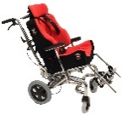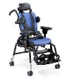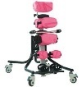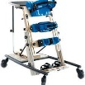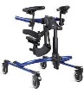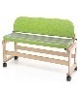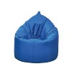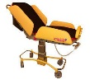

These are some orthotics we prescribe and refer to the orthotic Team for clinical assessment and provision to our students.

- Spinal Brace
- Ankle Foot Orthoses (AFOs) / LL Splints
- Contracture Corrective Devices (CCDs).
- Gaiters
- UL Splints
- Pedro Boots
- Head Guard

We also offer below interventions to our students.

- Physio tools Programme – Active and Passive Exercises
- Hydrotherapy
- Rebound Therapy

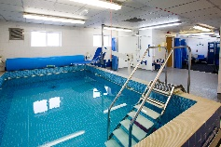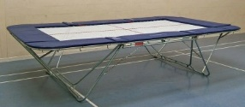

Referrals: As Physiotherapists we work as a team for holistic treatment for our students, based on this we can make referrals to the following Team for co-management of our students for effective clinical interventions.

- Birmingham Wheelchair Services (BWS)
- Seating Clinic/ Posture and Mobility Team
- Spasticity Clinic
- SALT including Dysphagia/ Nutrition Nurses (Usually done by Nurses)
- District Nurses
- Psychiatrists/Psychologists
- LD OT for Sensory Processing Issues

